Activity_main

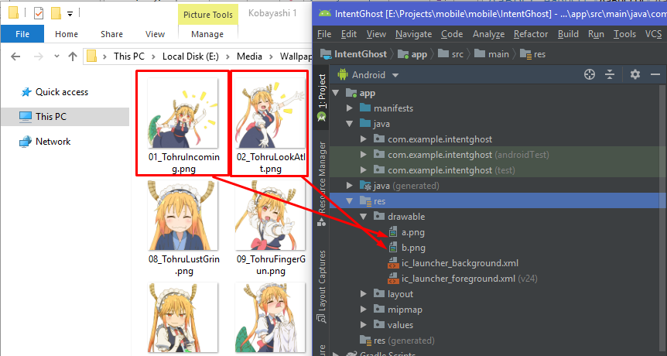

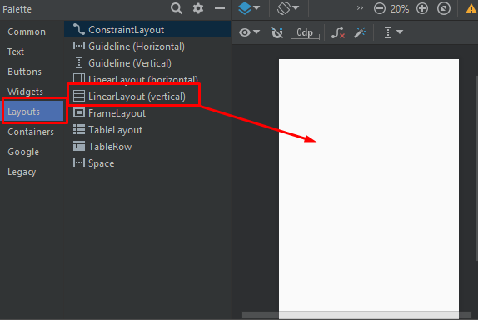

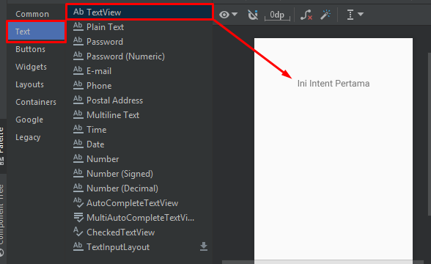

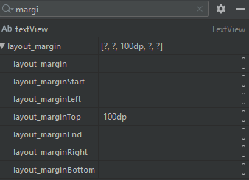 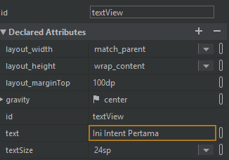

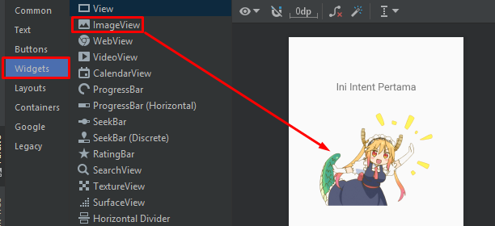 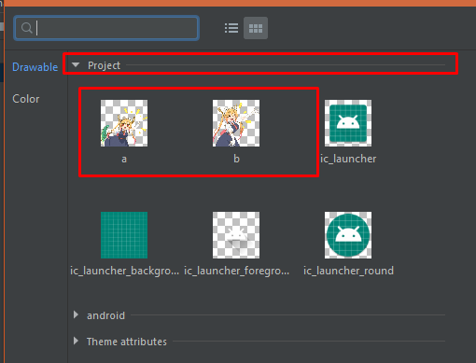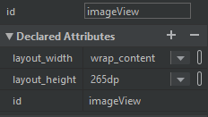

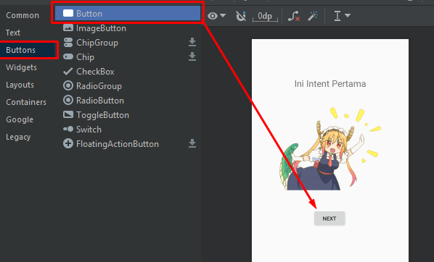

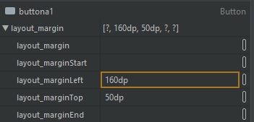 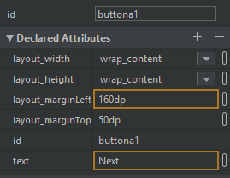

Kode activity_main.xml

|  |
| --- |
| <?xml version="1.0" encoding="utf-8"?>  <androidx.constraintlayout.widget.ConstraintLayout xmlns:android="http://schemas.android.com/apk/res/android"  xmlns:app="http://schemas.android.com/apk/res-auto"  xmlns:tools="http://schemas.android.com/tools"  android:layout_width="match_parent"  android:layout_height="match_parent"  tools:context=".MainActivity">  <LinearLayout  android:layout_width="match_parent"  android:layout_height="match_parent"  android:orientation="vertical"  tools:layout_editor_absoluteX="107dp"  tools:layout_editor_absoluteY="198dp">  <TextView  android:id="@+id/textView"  android:layout_width="match_parent"  android:layout_height="wrap_content"  android:layout_marginTop="100dp"  android:gravity="center"  android:text="Ini Intent Pertama"  android:textSize="24sp" />  <ImageView  android:id="@+id/imageView"  android:layout_width="wrap_content"  android:layout_height="265dp"  android:src="@drawable/a" />  <Button  android:id="@+id/buttona1"  android:layout_width="wrap_content"  android:layout_height="wrap_content"  android:layout_marginLeft="160dp"  android:layout_marginTop="50dp"  android:text="Next" />  </LinearLayout>  </androidx.constraintlayout.widget.ConstraintLayout> |

Kode MainActivity.kt

|  |
| --- |
| package com.example.intentghost  import android.content.Intent  import androidx.appcompat.app.AppCompatActivity  import android.os.Bundle  import com.example.intentghost.R  import kotlinx.android.synthetic.main.activity_main.*  class MainActivity : AppCompatActivity() {  val id:Int = 10  val language:String = "kotlin"  override fun onCreate(savedInstanceState: Bundle?) {  super.onCreate(savedInstanceState)  setContentView(R.layout.activity_main)  buttona1.setOnClickListener() {  intent = Intent(this, Main2Activity::class.java)  intent.putExtra("id_value", id)  intent.putExtra("language_value", language)  startActivity(intent)  }  }  } |

Activity_main2.xml

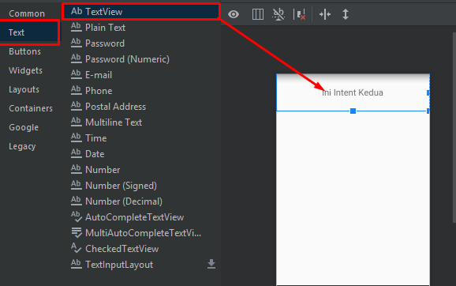

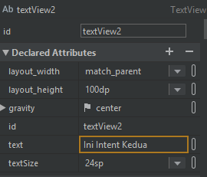

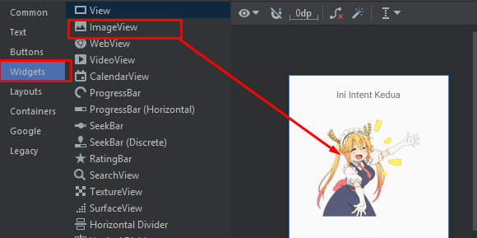 

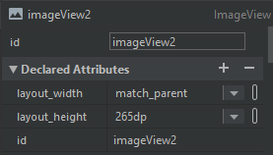

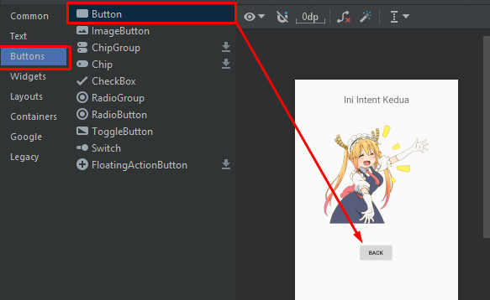 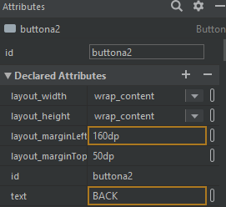

Kode activity_main2.xml

|  |
| --- |
| <?xml version="1.0" encoding="utf-8"?>  <androidx.constraintlayout.widget.ConstraintLayout xmlns:android="http://schemas.android.com/apk/res/android"  xmlns:app="http://schemas.android.com/apk/res-auto"  xmlns:tools="http://schemas.android.com/tools"  android:layout_width="match_parent"  android:layout_height="match_parent"  tools:context=".Main2Activity">  <LinearLayout  android:layout_width="match_parent"  android:layout_height="match_parent"  android:orientation="vertical">  <TextView  android:id="@+id/textView2"  android:layout_width="match_parent"  android:layout_height="100dp"  android:gravity="center"  android:text="Ini Intent Kedua"  android:textSize="24sp" />  <ImageView  android:id="@+id/imageView2"  android:layout_width="match_parent"  android:layout_height="265dp"  android:src="@drawable/b" />  <Button  android:id="@+id/buttona2"  android:layout_width="wrap_content"  android:layout_height="wrap_content"  android:layout_marginLeft="160dp"  android:layout_marginTop="50dp"  android:text="BACK" />  </LinearLayout>  </androidx.constraintlayout.widget.ConstraintLayout> |

Kode Main2Activity.kt

|  |
| --- |
| package com.example.intentghost  import android.content.Intent  import androidx.appcompat.app.AppCompatActivity  import android.os.Bundle  import com.example.intentghost.R  import kotlinx.android.synthetic.main.activity_main2.*  class Main2Activity : AppCompatActivity() {  val id:Int = 10  val language:String = "kotlin"  override fun onCreate(savedInstanceState: Bundle?) {  super.onCreate(savedInstanceState)  setContentView(R.layout.activity_main2)  buttona2.setOnClickListener() {  intent = Intent(this, MainActivity::class.java)  intent.putExtra("id_value", id)  intent.putExtra("language_value", language)  startActivity(intent)  }  }  } |